**title: "Bike Share Analysis from May 2021 - April 2022"**

**author: "Victor Okafor"**

**date: '2022-06-24'**



**About the company**

In 2016, Cyclistic launched a successful bike-share offering. Since then, the program has grown to a fleet of 5,824 bicycles that are geo tracked and locked into a network of 692 stations across Chicago. The bikes can be unlocked from one station and returned to any other station in the system anytime.

**Business Task**

We are going to take an in depth look at these data sets to understand how the two user types groups (Annual members and casual users) make use of the cyclistic bikes differently.

**About the Data**

You will use Cyclistic’s historical trip data to analyze and identify trends. [Download the previous 12 months of Cyclistic trip data here.] (https://divvy-tripdata.s3.amazonaws.com/index.html) Note: The datasets have a different name because Cyclistic is a fictional company. For the purposes of this case study, the datasets are appropriate and will enable you to answer the business questions. The data has been made available by Motivate International Inc. under this [license.] (https://ride.divvybikes.com/data-license-agreement))

This is public data that you can use to explore how different customer types are using Cyclistic bikes. But note that data-privacy issues prohibit you from using riders’ personally identifiable information. This means that you won’t be able to connect pass purchases to credit card numbers to determine if casual riders live in the Cyclistic service area or if they have purchased multiple single passes.

**Key Stakeholders**

* **Lily Moreno**: The director of marketing and your manager
* **Cyclistic marketing analytics team**: A team of data analysts who are responsible for collecting, analyzing, and reporting data that helps guide Cyclistic marketing strategy.

**Analysis and Visualizations**

Analysis of user types.

This is to help us quantify the different customer groups patronage within the last 12months.

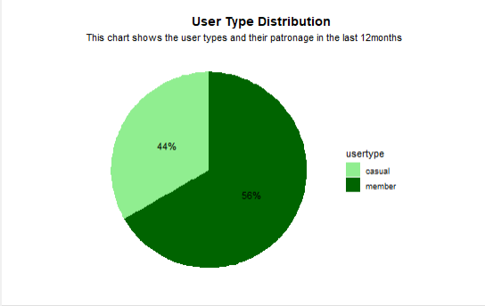

**Observation**

* The chart above shows the member user type (3,221,193) makes up a major part (56%) of our customers while the casual (2,536,358) users make up 44% of our patronage in the last 12 months.
* While is impressive we believe more can still be done to convince our casual users to convert to a more profitable user model.

**Let's visualize the number of rides by rider type**

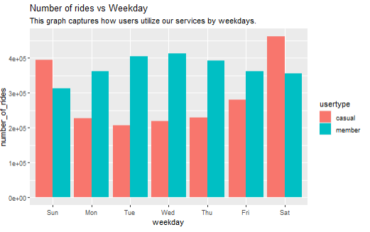

**Observation**

* From the visualization above it can be observed that member user types use cyclistic more of often than the casual user types during the mid-week but on weekends the casual user types make use of cyclistic more often.
* This trend could be interpreted to mean that member user types are working class who use bikes to commute to and or from work in order to keep fit.

**Let's visualize the Rider type by Ride duration**

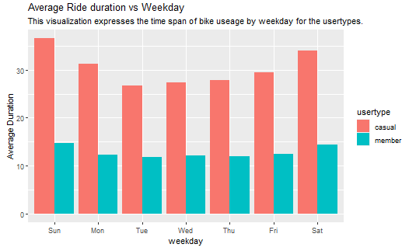

**Observation**

* The visualization above shows weekday trends that reveal that casual user types use cyclistic for average more duration than member user types.
* This means that our casual user types find our bikes more appealing for long trips.

**Let's Analyze bike usage by time of the day**

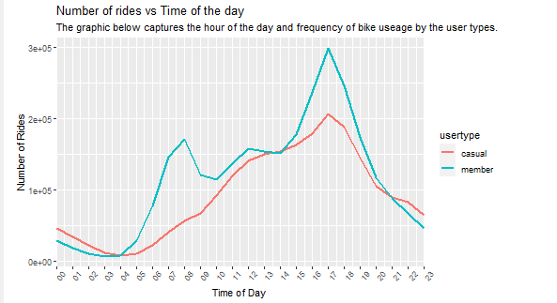

**Observations**

* The visual above captures the hourly usage of bikes by our user types. from the above we can infer that member peak usage is 5:00 PM in the evening.
* It can also be observed that there is a rapid increase in demand for bikes by casual user types from 6:00AM till 5:00PM.

**Let's visualize rides by months covered in this analysis**

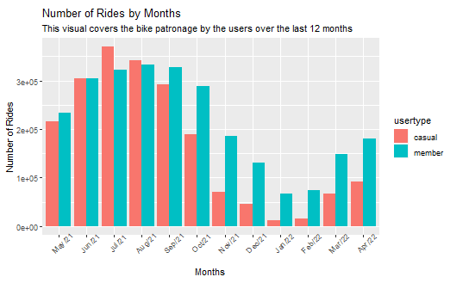

**Observation**

* Scrutiny of this graph reveals that patronage by the casual user type peaks in summer months.
* According to the national geographic website, summer begins June 1. This visualization signals that the casual user types begin to make use of our bikes more often from the end of spring till autumn when casual patronage begins to decline again.
* This means there is a correlation between bike usage and seasonality.

**Average duration by months**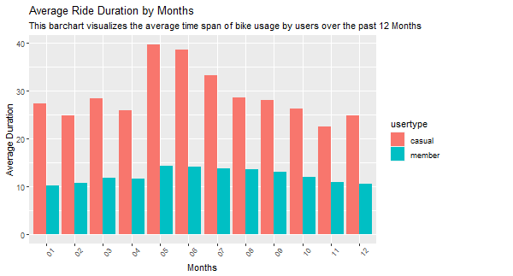

**Observation**

* The graphic above expresses that the duration of ride by members are relatively stable all year round while that of the casual users are higher all year round and peaks around summer months.

**Analysis of type of bike used by customer types**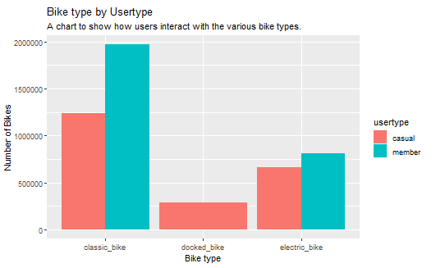

**Observation**

* The visual above conveys that both user types make use of the classic bikes more than the other bike types.
* The members did not make use of the docked bike which is perplexing.

**Summary and recommendations for Cyclistic membership:**

**What is Cyclistic annual membership?**

Cyclistic Annual membership is one of the user type group offered by cyclistic which enables users to pay a onetime fee that allows them unlimited access rides all year round.

**Insights from the data**

* Majority of our bike users are Annual members.
* Casual users make use of bikes more often on weekends but there is a stable usage of bikes by annual members weekdays and increases a little on weekends. This a signal that our members commute to work with their bikes a lot.
* Casual users begin to ride demand begins to rise during spring, peaks during summer and begins to decline during fall. For annual members it is almost the same except demand doesn't decline as quickly during fall.
* Annual users tend to use bikes for shorter trips than casual users. The average trip duration of casual users is more than double that of Annual members in peak months of summer and few steps shy double all year round.
* Generally, members pick more rides through the day but bike usage peaks around 05:00PM daily for the member user type groups however there is smaller peak during morning rush hours. while casual users demand rise gradually till it peaks in the evening as well.
* while it is perplexing, it is still worthy of note that the member user type did not make use of docked bike in the last 12months. The favorite bike of the both users is the classic bike.

**Recommendations**

Target Audience: 9 - 5 Workers

* Ad campaigns should be targeted towards single young adults and middle age workers whose work place is not too far from their homes.
* Casual users of middle age should be targeted with digital ads from afternoon to evening period because that's when they are most active.
* Ads should emphasize reasons why taking bikes during colder months is very necessary and how a membership will help casual users stick to bikes.
* Ads should help users know that short trips over long periods will keep them fit always and how enrolling for memberships will help them ensure they take those bike trips.
* Pricing should reflect that it is economically smarter to enroll for membership. (for regular casuals.)
* It could also not hurt to introduce monthly memberships.